Final Report

Ifreador Aziagbe

Course number: DATA 205

CRN: 34669

Professor: Lori A. Perine

Project title: Analyzing the Impact of Socioeconomic Factors on Traffic Crash Frequency and Severity in Montgomery County.

Introduction(overview):

Income Dataset – Provides median household income estimates for 46 ZIP codes, sourced from: [**https://data.census.gov**](https://data.census.gov), [**https://www.incomebyzipcode.com/maryland/**](https://www.incomebyzipcode.com/maryland/), and [**https://worldpopulationreview.com/zips/maryland**](https://worldpopulationreview.com/zips/maryland)

Crash Reporting Dataset – Contains detailed records of traffic collisions collected by the Maryland State Police through the Automated Crash Reporting System (ACRS), with reports from county and municipal police. Source: [**Montgomery County Data | Open Data Portal**](https://data.montgomerycountymd.gov/).

Crime Dataset – Includes reported crime data classified under the National Incident-Based Reporting System (NIBRS) and compiled using the EJustice system, widely used by local law enforcement.: [**Montgomery County Data | Open Data Portal**](https://data.montgomerycountymd.gov/).

Goals:

Goal 1: To analyze, understand, and potentially predict the key factors that contribute to the severity and frequency of traffic crashes in Montgomery County

Goal 2: Examine how traffic crash rates in Montgomery County vary by household income levels across ZIP codes, as well as crime report incidents

These goals are important because they use data to make Montgomery County safer and fairer for everyone. Instead of just dealing with crashes *after* they happen, these goals try to figure out *why* they happen in the first place, so we can stop them from happening.

Tools:

Python Libraries: *Pandas*, *NumPy* for data wrangling; *Seaborn*, *Matplotlib*, *Plotly* for visualization; Geospatial Analysis: *Folium* for mapping crash hotspots; Statistical Tests: *Chi-square* for categorical relationships; *correlation analysis* for numerical relationships, and Documentation: *Jupyter Notebooks*, with version tracking and code comments.

Summary of data cleaning / Pre-processing: I corrected misspellings, excluded categories like route type and lane direction. In addition, I merged the crash and crime datasets using ZIP code as a common key to analyze their relationships. I extracted the time and day of the crash from the crash date to analyze time and day-based trends. Finally, I standardized column names and formats.

Basic descriptive statistics. The Crash dataset has 37 columns and 111k rows, and the crime dataset has 30 columns and 442k rows. The peak crash time is 3 – 6 p.m. Friday, which has the highest number of crashes. In addition, the Chi-square test between Hit and Run and Road conditions: p_value = 0.0; scatter plot shows a strong positive correlation (r = 0.94) between crime count and crash count by region. However, the scatter plot and correlation show a weak negative relationship between median household and crash count (r = -0.082)

Descriptive of the final data product:

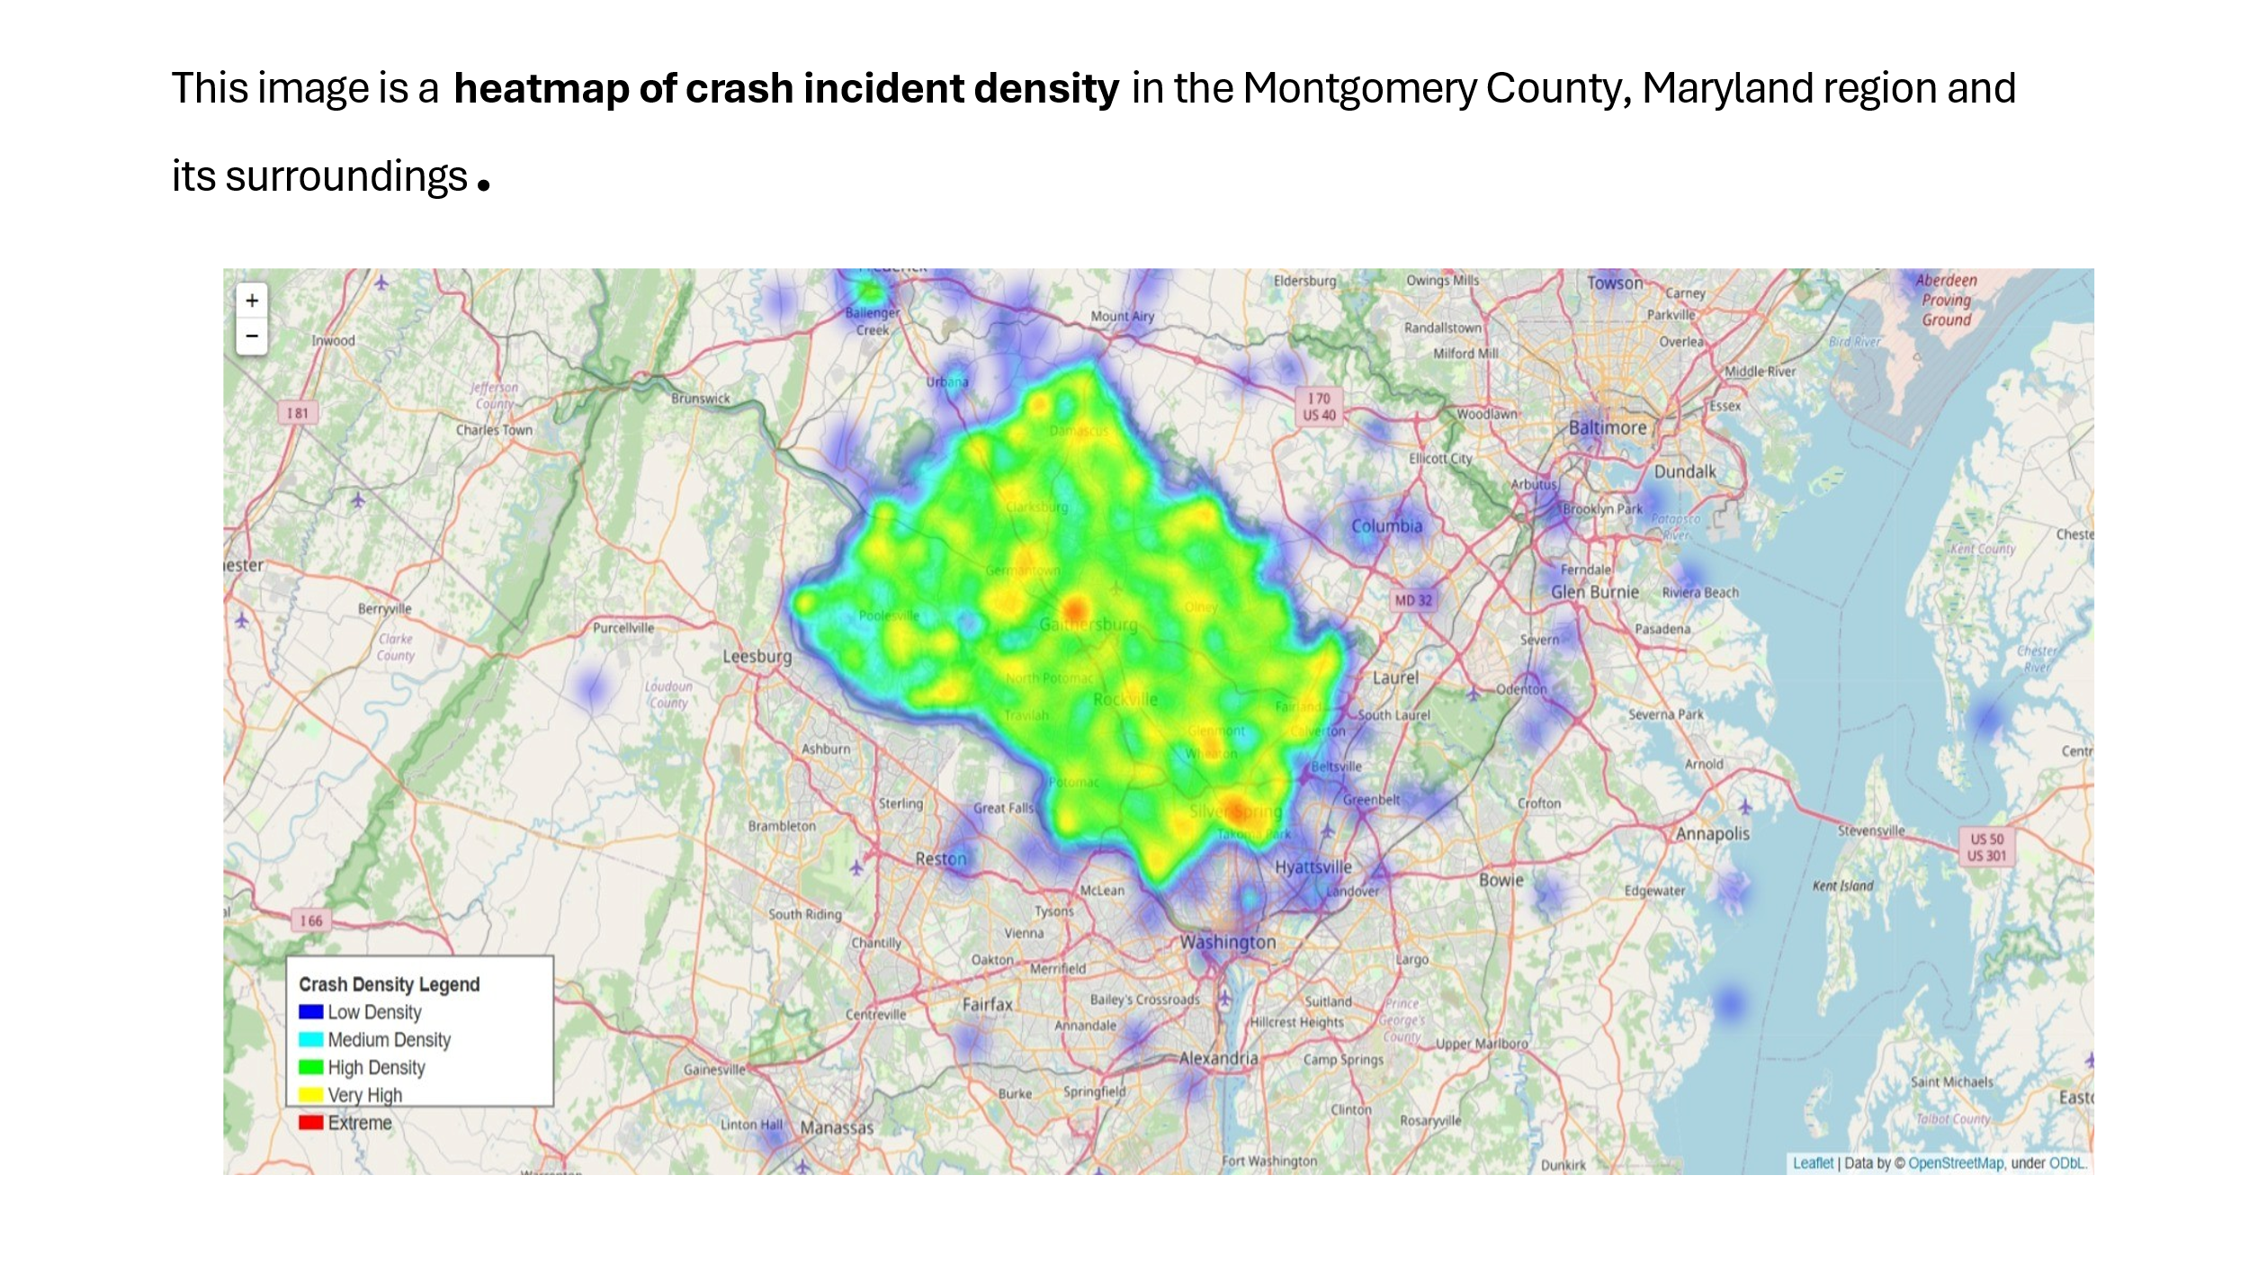Result:

The areas with the highest crash density, shown in red and yellow, are Gaithersburg, Rockville, and Germantown. Silver Spring also indicates a very high crash concentration. Also, Areas like Poolesville, North Potomac, and Olney show moderate crash density (green). In addition, Peripheral zones like Leesburg, Annapolis, and Bowie exhibit low crash activity (blue or barely visible).

Density Level Number of Locations

0 Low (Blue) 22047

1 Medium (Cyan) 188

2 High (Green) 27

3 Very High (Yellow) 2

4 Extreme (Red) 1

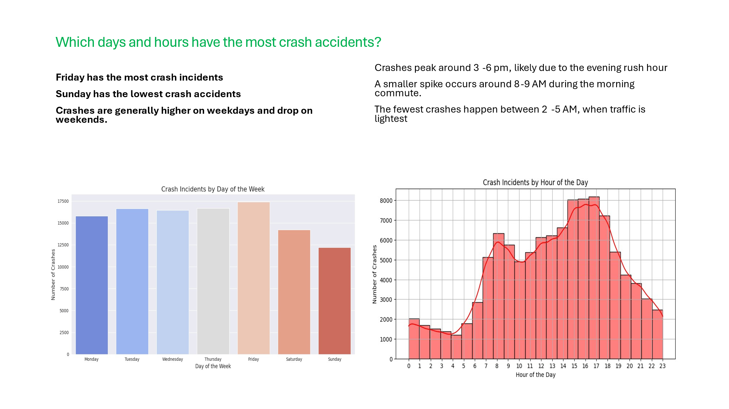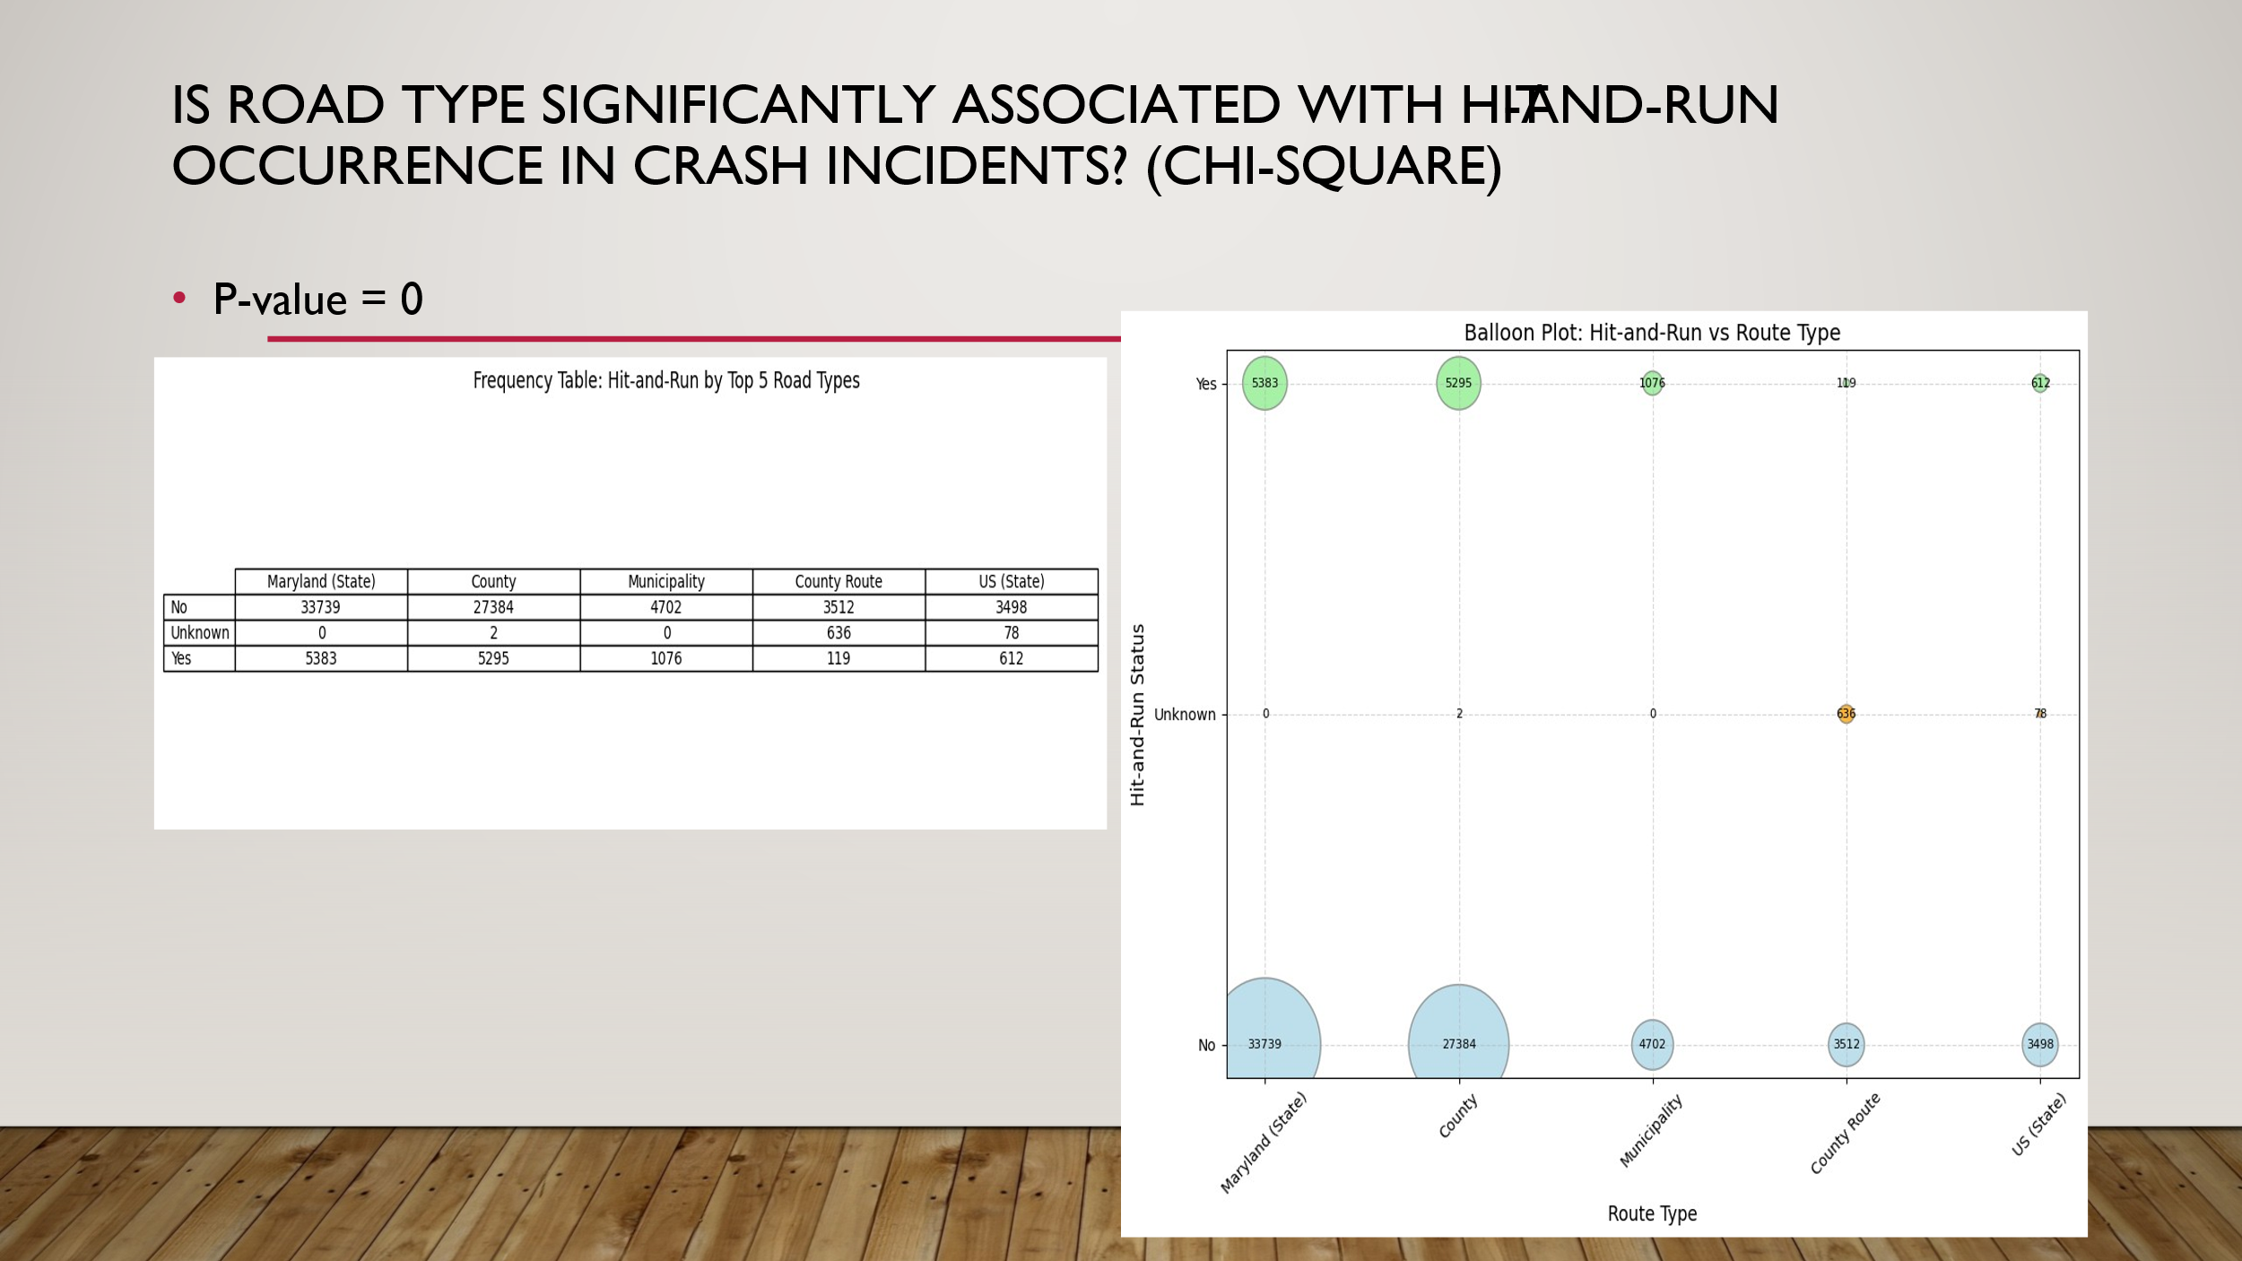

Most hit-and-run events happen on Maryland state and county roads, possibly due to higher traffic or anonymity. Also, the lowest cases appear on county routes and US state roads. Finally, P-value = 0; this indicates a statistically significant relationship between road type and whether a crash is hit-and-run.

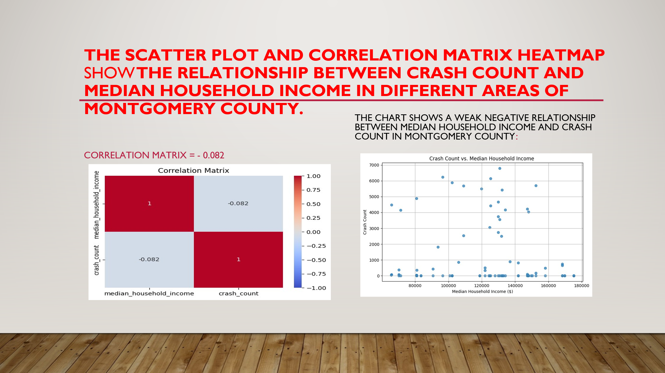

The correlation matrix is – 0.082, which means no linear relationship between income and crash count. The scatter plot shows points scattered widely, without a clear trend line. Crashes occur across all income levels. Also, there is no clear pattern where higher or lower income consistently predicts more or fewer crashes. Therefore, income level does not significantly influence crash frequency in this dataset.

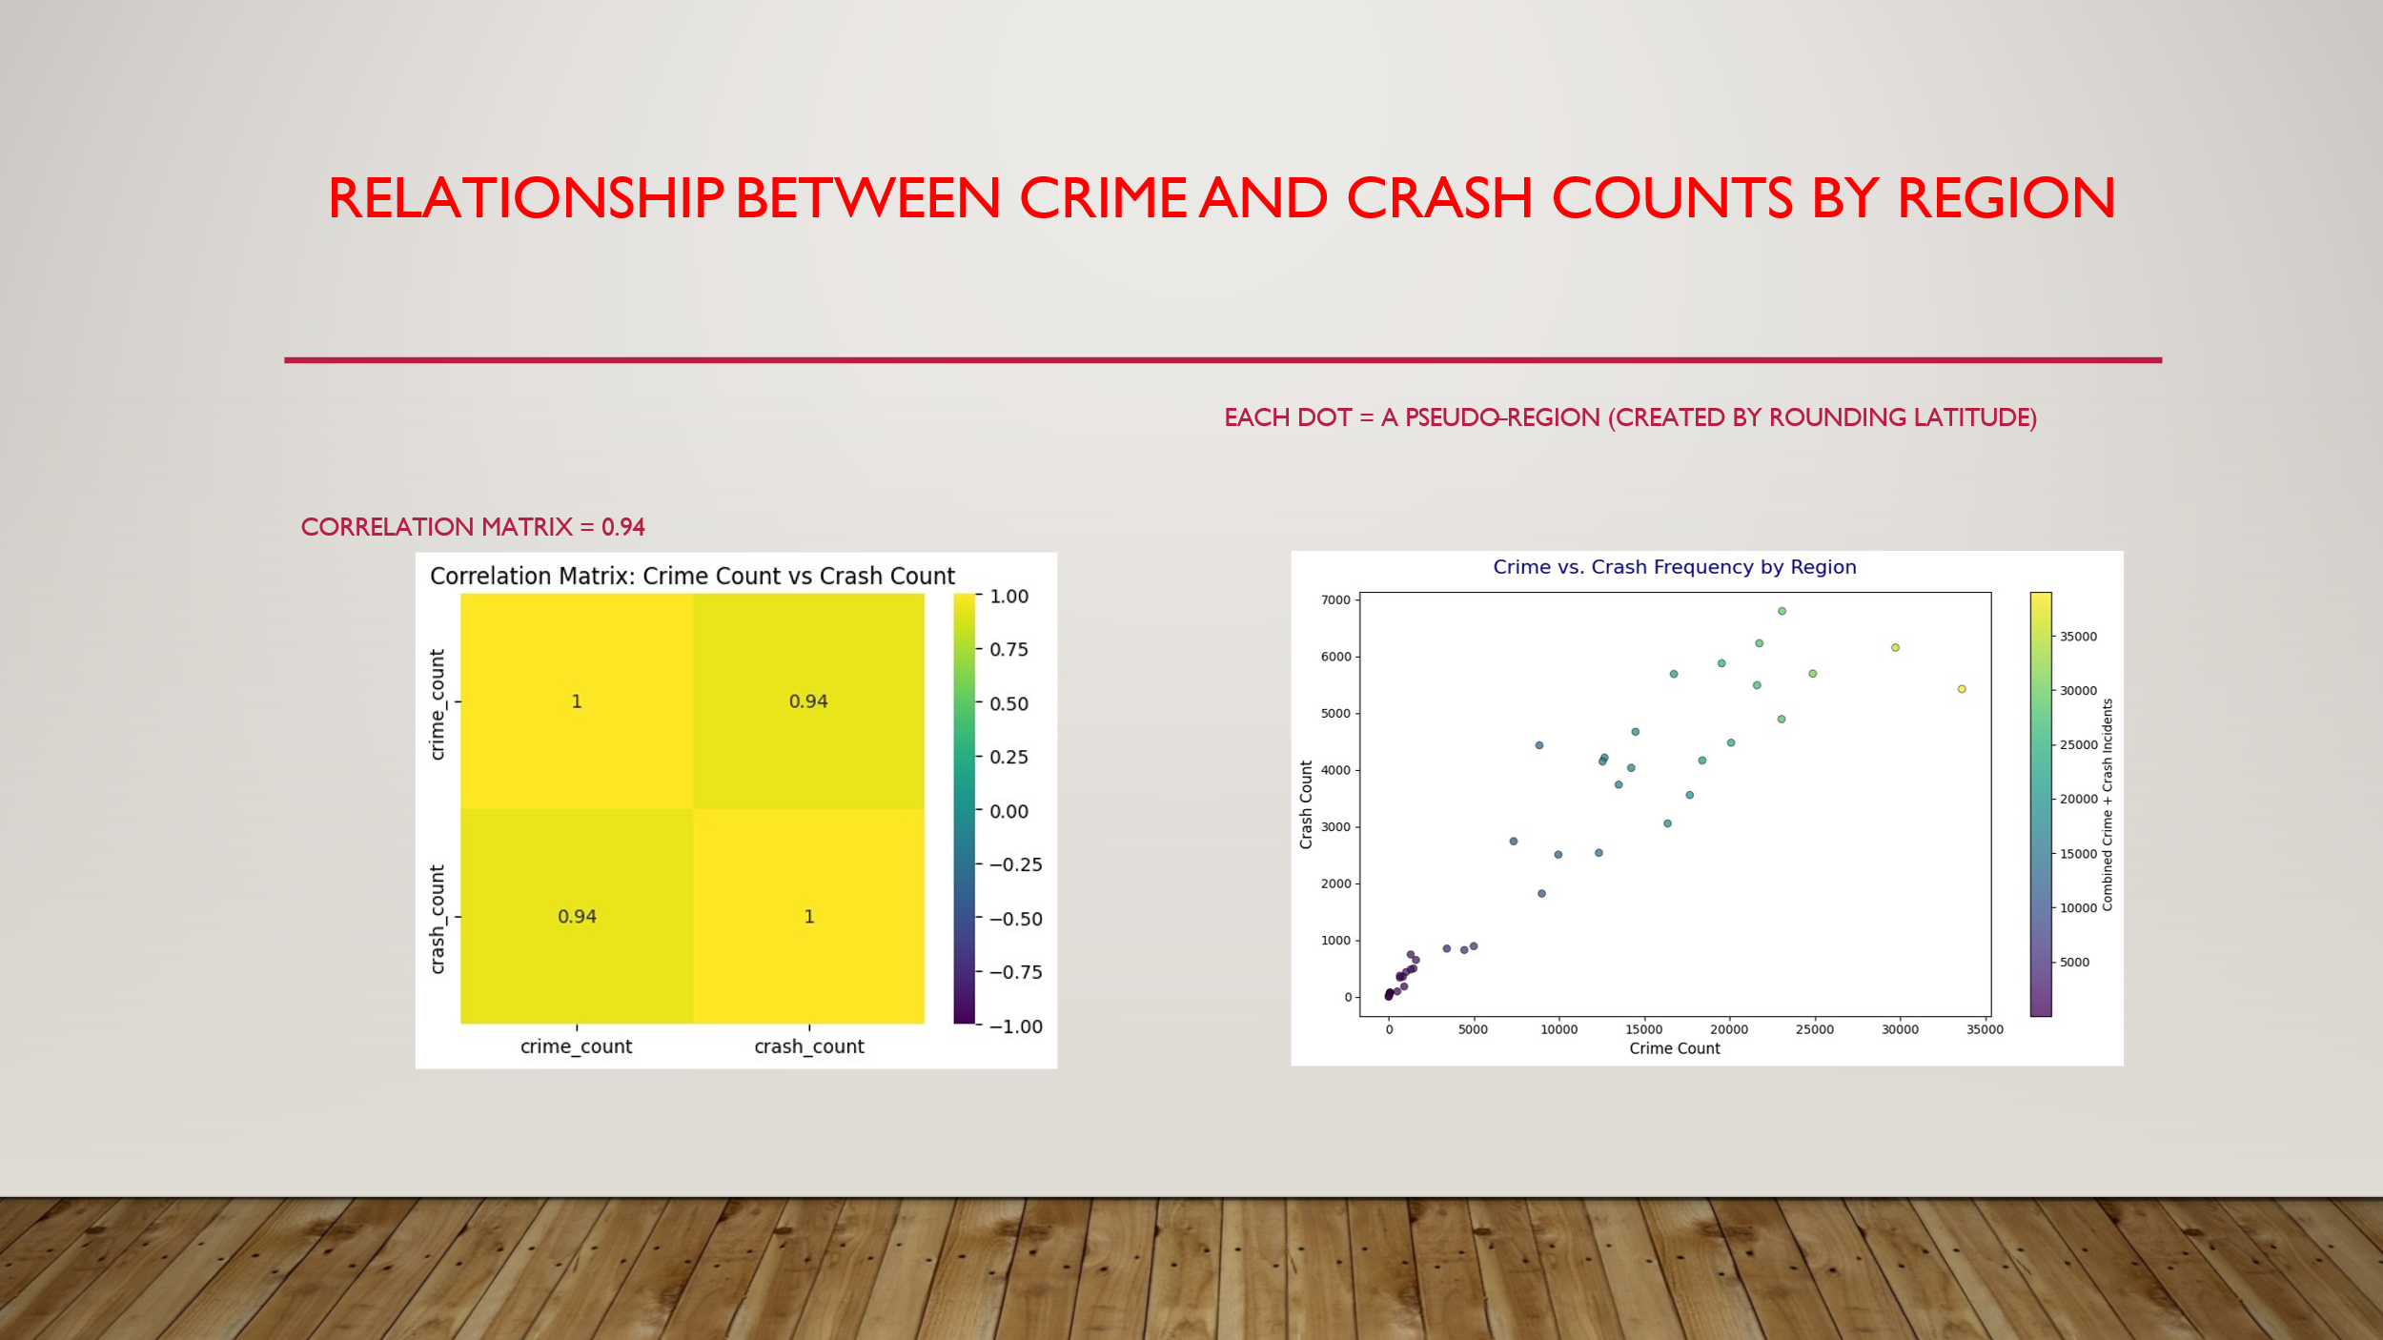

Correlation Coefficient: 0.94. This is a very strong positive correlation; as crime counts increase in a region, crash counts also tend to increase. Also, each dot represents a pseudo-region (made by rounding the latitude). Finally, the scatter plot shows a clear upward trend; regions with high crime counts also have high crash counts.

Overall, crash incidents in Montgomery County are strongly linked to high-crime areas, especially in urban centers. Income has little effect on crash rates. Most crashes happen during rush hours and on weekdays, with hit-and-run cases more common on state and county roads. These findings highlight the need for targeted safety efforts in high-risk zones and times.

References and acknowledgement:

Acknowledgements

I sincerely thank my professors for their guidance and support throughout this project

•Professor Alraee   
• Professor Perine   
• Professor Mohamed

References:

[**https://data.census.gov**](https://data.census.gov/), https://www.incomebyzipcode.com/maryland/, [**https://worldpopulationreview.com/zips/maryland**](https://worldpopulationreview.com/zips/maryland)​[**Montgomery County Data | Open Data Portal**](https://data.montgomerycountymd.gov/)